6th Grade Reading Supply List

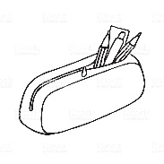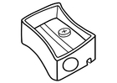
- 1 “ Binder (Clearview/clear plastic cover)
- 5 tab dividers without pockets
- College Ruled notebook paper
- Pencil pouch (stored inside the binder)
- 3 non-mechanical pencils
- Hand-held sharpener
- Sharpie
- Colored pencils (red, yellow, blue, green, and orange)
- 1 highlighter
- 1 pack of post it notes

Donations

Tissue paper
Paper Towels
Hand sanitizer

