http://wiseguystpt.blogspot.com/2011/01/miraculous-journey-of-edward-tulane.html

The Miraculous Journey of Edward Tulane
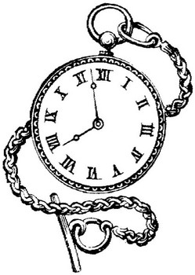
End of Novel Project Choices

The following choices will be due at the end of the novel. You will
most likely have some time in class to complete this, but you may
have to do some at home.

Names for Edward
Edward had many names throughout this novel. You are asked to come up with 10 other names for Edward. In addition to the names, you must also include an explanation of how the name has to do with something that happened in the story.
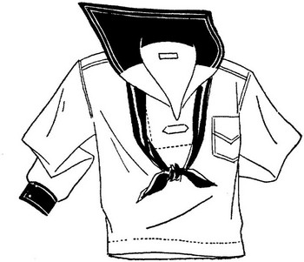

Outfits
Edward had several unique outfits throughout the story. You are asked
to design at least three outfits for Edward. You must draw a colorful
picture of the outfits and provide a brief explanation about where in the
book Edward would wear each outfit. For some extra credit, you could
actually make one of the outfits out of real cloth!

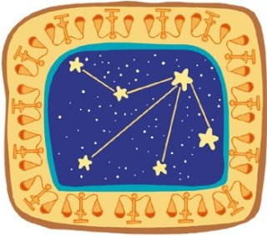
Constellations
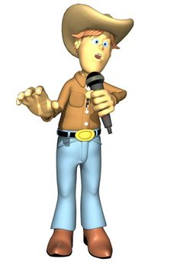
Throughout the story, constellations and stars are mentioned often. You are asked to research and draw five constellations. You must draw each constellation and then provide some history or other interesting information.

Create a Song
You are asked to create a song that Bull would have sung about
Edward Tulane. Your song must include events from the story.
It must include at least 3 verses (at least 4 lines long) and a chorus
(at least 5 lines long).

Collage
Choose a character from The Miraculous Journey of Edward Tulane that you find most interesting. Create a collage that is about this character. On the back of the collage, write a paragraph (5 sentences) about why you chose the pictures that you did.

