How a Billboard About Blueberries in Michigan Inspired a Movement
by Delaney Faught — Jun 1, 2018 in Featured / Kindness In School / Kindness In The Community
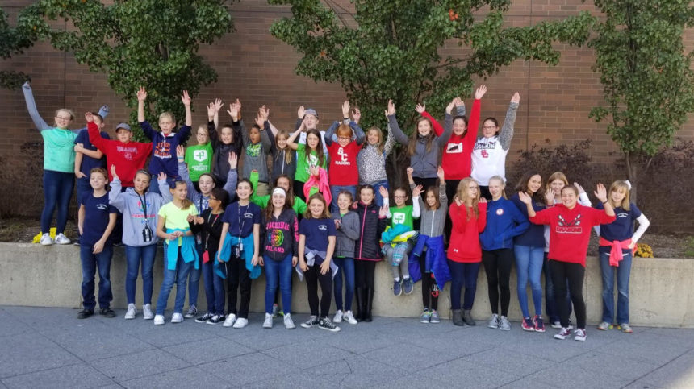
Courtesy of Jennifer Dikos.
It was a normal day on Interstate 69 in Genesee County, Michigan. Hundreds of people were making their usual commute when a new billboard started to catch some attention. Over the next few weeks, residents started to infer what the giant sign that read “I’m Concerned About The Blueberries” could really mean. The guessing game went on for some time until one man, Phil Shaltz, came forward.
Phil, a local entrepreneur and active community member in Flint, was the owner of the now local iconic structure. When asked in 2013, he shared with MLive about getting the idea for the billboard while on an Alaskan cruise. During a zip-lining adventure, he and his wife were getting a tour from some local young people. Another tourist in the group asked one of the guides how things were going. To the tourists, this young man seemed to have an easy-going life.The man responded that things were “just OK.” They prodded, and that was how the famous line came to be: “I’m concerned about the blueberries.” Apparently, the young man was concerned about the blueberry crop due to lack of rain that season. At first, Phil thought this seemed so simplistic, but then he realized the greater humanity in this predicament.
“He cannot impact his concern about the blueberries because he cannot impact the amount of rain in Alaska,” Phil told MLive. “Then I thought about the other issue. We all go through the day and we see people who have blueberries – their own issues – and we don’t do anything. Even when it’s not about rain, when it’s something we can impact, we show just how desensitized we’ve become. We aren’t as helpful to the common man in even the small things in life.”
So he constructed a billboard, and it turned heads, but the ripple effect didn’t stop there. This simple phrase grew into movement lead by Blueberry Ambassadors. The ambassador program started with just 100 students, but the effort has since grown to over 1,000 young people across Genesee County. Their goal: perform random acts of kindness, write about them, and hopefully relieve some of those blueberries for someone else.
This program is unique in that it is largely student-driven. At Swartz Creek Public Schools, Lena, a sixth-grade student, approached one of her teachers to start the program. She had heard about the Blueberry Ambassadors outside of school, and she wanted to her school to be a part of it. Now, the district sees more Blueberry Ambassadors every year.
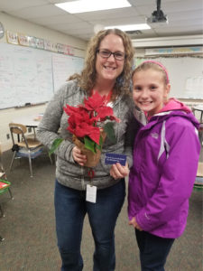
“Kids naturally want to help others,” Jennifer Dikos, a teacher who works with the ambassadors at Swartz Creek, said. “As adults, it’s easy to get caught up in our daily lives and everything else, but they remind us why that’s important.”
Jennifer has been involved with the program since its inception at her school. She explained that every student gets three cards at the beginning of the school year to symbolize their commitment to three acts of kindness. Students work with each other and an adult supervising the program to carry out and write about their Blueberry Moments. Through partnerships with MLive and The Flint Journal, their stories are shared online so that others can read them.
After the Blueberry Moment is complete, the ambassador passed their card on to the person involved.
“And a lot of times,” Jennifer said, “people will take the card and pass it to someone else,” thus starting a chain reaction of good deeds.
Just in the past year, a sampling of Blueberry Moments included anything from kids helping their parents cook dinner to a group of ambassadors visiting a senior center with ornaments they made. Reading their stories, it’s clear that the Blueberry Ambassadors feel the impact of their own good deeds as well.
Below are just a few samples of what they’ve said about how their Blueberry Moments made them feel:
“That gave my heart a shot of kindness.” -Rebecca, as seen on MLive, Blueberry Moment 11002
“They smiled and it felt good to make them smile!” -Makenzi, as seen on MLive Blueberry Moment 11030
“It’s not the money that counts, it’s the kindness that does.” -Rithvik, as seen on MLive
Every year, more kids make an impact through the Blueberry Ambassadors program. They are showing the power of kindness and young people in their communities. In 2017, it was announced that due to such growth, the program would continue for another year.
When asked what her favorite act of kindness has been, Jennifer thought of Lena.
“She was out to dinner with her family and they saw an older man sitting by himself,” she said.
Lena’s family asked their waiter if they could cover the man’s bill. When he realized what happened, he approached them to say thank you.
“And then they invited him to sit down with them,” Jennifer said.
She explained that Lena’s family spent the rest of the evening getting to know this man. He shared that he lived alone and enjoyed spending some time with them. This Blueberry Moment wasn’t planned – Lena simply used the tools the Blueberry Ambassadors had given her to recognize the blueberry in this man’s life: loneliness. And in that moment, she was able to share her kindness with him.
Want to start a Blueberry Ambassador program at your school? Visit http://www.imconcernedabouttheblueberries.com/contact.html or contact the group via Facebook for more information.To read more Blueberry Moments, visit https://topics.mlive.com/tag/flint-blueberries.

