Rep. Roybal-Allard, 24 Cosponsors Reintroduce CARE Act to Strengthen Protections for Child Farmworkers

Washington, June 20, 2019 | Ben Soskin ((202) 225-1766) | comments
Today, Congresswoman Lucille Roybal-Allard (CA-40) led the reintroduction of her Children’s Act for Responsible Employment and Farm Safety (CARE), which raises labor standards and protections for farm worker children to the same level set for children in all other occupations. The congresswoman announced the CARE Act’s reintroduction at a press event in the U.S. Capitol alongside advocates including Mónica Ramírez, the president of Justice for Migrant Women; Norma López, the chair of the Domestic Issues Committee for the Child Labor Coalition; and Brenda Alvarez-Lagunas, a former child farmworker who recently made national news for her valedictorian speech at her high school graduation. Congresswoman Roybal-Allard reintroduced today’s bill with 24 House cosponsors.
“America is morally obligated to protect the rights, safety, and future of every child in our nation,” said Congresswoman Roybal-Allard. “Sadly, our child agricultural workers do not enjoy these protections. They currently face a double standard that lets them work at younger ages, for longer hours, and in more hazardous conditions than child workers in any other industry. If we value our youth, if we support fair and decent treatment for all children, then we must pass the CARE Act and finally ensure fundamental protections for America’s child farmworkers.”
“Farmworker children pay the price for the inexpensive fruits and vegetables our nation consumes with their battered bodies, lost educational opportunities, and broken dreams because they are forced to work just to make ends meet for their families,” said Ms. Ramírez. “The CARE Act seeks to put farmworker children on equal footing with other children by placing necessary restrictions on their ability to work in one of the most dangerous jobs in the US.”
“Today in America, as many as 500,000 children are performing back-breaking and often dangerous work on farms across the country with few protections, no safety training or equipment, and for very low wages,” said Ms. López. “They are sacrificing their childhood, their education, and their health to help put food on their family’s table; yet the most they earn in a year is $2000. America’s future is worth so much more. It is time to end the double-standard farmworker children face and extend equal protections to all of America’s children. It is time to pass the CARE Act.”
“I was in the fields as young as seven years old with continued exposure to harmful chemicals,” said Ms. Alvarez-Lagunas. “I was working under the sun for hours at a time – this is why I am grateful for Roybal-Allard’s CARE Act. It will help protect children from harmful conditions.”
“Why must we rely on children to harvest fruits and vegetables in America?,” said Reid Maki, director of child labor advocacy of the National Consumers League and coordinator of the Child Labor Coalition. “Why must Latino children bear the brunt of unjust laws? The child labor exemptions in U.S. labor law constitute a de facto form of discrimination and why allow young children to work in what is the most dangerous industry? These loopholes have been around since the enactment of the Fair Labor Standards Act in 1938. Isn’t it time to protect all our children equally?”
Under current law, children in agriculture are allowed to work at younger ages and for longer hours than those working in other sectors. Children as young as 12 can work with virtually no restrictions on the number of hours they spend in the fields outside of the school day. Furthermore, children performing hazardous agricultural work can be as young as 16, while hazardous non-agricultural work is reserved for adults. With the majority of work-related fatalities for children occurring in the agriculture sector, and past findings that child agricultural workers drop out of school at four times the national dropout rate, it is imperative for Congress to take action to protect these child workers.
Key provisions of the CARE bill:
While retaining current exemptions for family farms and educational programs like 4-H and Future Farmers of America, the CARE Act:
• Brings age and work hour standards for children in agriculture up to the standards for children working in all other industries:
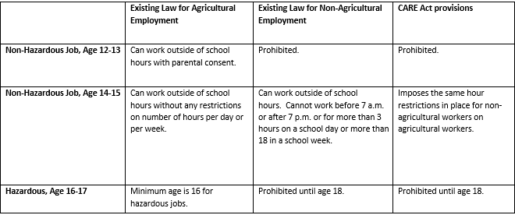
• Establishes a minimum penalty for child labor violations;
• Increases the maximum civil monetary penalties and maximum criminal penalties for child labor violations;
• Provides children with greater protections against pesticide exposure in agriculture by raising the labor protections to EPA standards.
• Includes reporting requirements on work-related injuries and serious illness.
The CARE Act’s original cosponsors include Congressmembers Nanette Diaz Barragán (CA-44), Karen Bass (CA-37), Tony Cárdenas (CA-29), David Cicilline (RI-01), Yvette Clarke (NY-09), Rosa DeLauro (CT-03), Ruben Gallego (AZ-07), Sheila Jackson Lee (TX-18), Marcy Kaptur (OH-09), Barbara Lee (CA-13), Andy Levin (MI-09), Alan S. Lowenthal (CA-47), Stephen F. Lynch (MA-08), James P. McGovern (MA-02), Gwen Moore (WI-04), Grace F. Napolitano (CA-32), Eleanor Holmes Norton (DC), Mark Pocan (WI-02), Gregorio Kilili Camacho Sablan (MP), Janice D. Schakowsky (IL-09), Adam B. Schiff (CA-28), José E. Serrano (NY-15), Albio Sires (NJ-08), and Frederica S. Wilson (FL-24).
https://roybal-allard.house.gov/news/documentsingle.aspx?DocumentID=401599

