How Students are Bringing Kindness and Positivity to Hospitals

throughout the United States

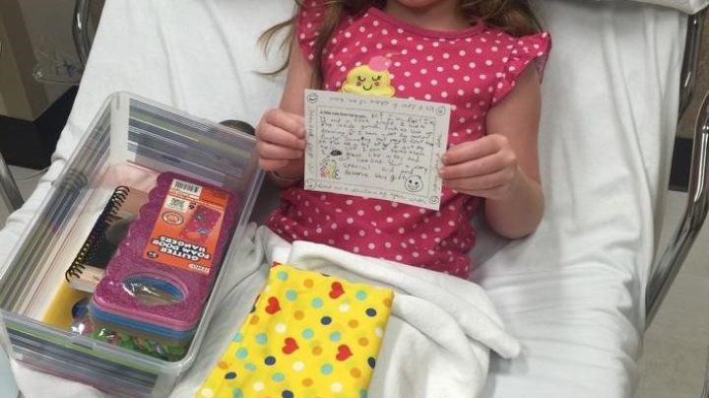
by Nora Smith — Jun 15, 2017 in Kindness In The Community

In 2001, students from a local Catholic school, in State College, PA, Our Lady of Victory, came together to honor a friend and classmate they lost to cancer in November of 2000. In 1999, Jared, an elementary student, had been diagnosed with an incurable brainstem tumor. Jared continued to enjoy his childhood through play by bringing his backpack, filled with toys, to his doctor’s appointments. He often questioned why other kids did not bring toys with them to their appointments, and began sharing his toys with others.
The Jared Box Project aims to bring play and joy to kids in the hospital. A Jared Box is a plastic storage box filled with gifts, toys, and activities for children in the hospital. Each box is aimed towards a specific gender and age. The boxes allow for diversion from harsh medical treatments and lift children’s spirits. Over 200,000 boxes have been delivered to hospitals across the United States.
I was fortunate enough to interview a current 6th grade student at Our Lady of Victory School, Cate Saylor who has made Jared Boxes with her family.
Have you created a Jared Box before?
Every year my family creates one, and I get to help pick out some of the stuff. My family came to State College 2 years ago, and we’ve been doing them since I was in 4th grade.
How is this project an act of kindness?
It really helps kids in hospitals who are upset, or they don’t have anything to do. I’ve been in the hospital before and know how tough it can get. The Jared Box is an act of kindness because it brings children happiness.
Is it ever hard to select items for the box, since you don’t know specifically who it is for?
It is hard, but I have a little brother and so we get things that we know he would like which makes it easier.
After my interview with Cate I was able to interview a second person, Cindy Kolarik. Cindy is the current director of the Jared Box Project.
What is your position with the Jared Box Project and how did you get involved? Do you ever interact or work with current OLV students?|
I volunteer and serve as the Director of the Jared Box Project. What a joy it has been to watch this project grow and spread across the country. I am one of the founders of the project. After Jared passed away, a few of us got together and wanted to do something to honor Jared’s memory. He was very courageous, had a strong faith and caring spirit. We had all heard how Jared was always thinking of others, how he invited other children in the hospital to join him in a game of UNO or Old Maid. We took Jared’s caring spirit and used it as our inspiration. We decided to create boxes filled with games and toys, personal notes of well wishes and love. These boxes would be given to children in the hospital. We named the boxes after Jared and what happened next still is quite unbelievable! The idea just took off. Hospitals wanted boxes, people wanted to make boxes and kids loved receiving boxes. Over 250,000 Jared Boxes have been made in all 50 states.
The Jared Box Project was started at Our Lady of Victory School, the school the Jared attended. Each year, the students at OLV make Jared Boxes and donate them to Geisinger Janet Weiss Children’s Hospital. That is the hospital where Jared was treated.
How is the Jared Box Project an act of kindness in your eyes?
The Jared Box Project is the perfect example of a simple act of kindness. I often hear that Jared Boxes are as fun to make as they are to receive. Jared Boxes are inexpensive and easy to make. Supplies are readily available at stores such as Dollar Stores, Walmart and Target. As you assemble a box, you can imagine how much fun it will be for the child receiving the box. Personalized handwritten notes included in each box are an extra special form of kindness. One of my favorite quotes is from Mother Theresa, “Do small things with great love.” That quote captures the essence of the Jared Box Project. I see it each day as we receive thank you notes and pictures of children opening their Jared Box. They just can’t believe that someone that don’t even know made this box filled with fun and love for them! Jared started a wave of kindness that continues still today.
How can the project continue to create and highlight kindness within different communities?
I have realized that people are kind and caring by nature. The Jared Box Project does a good job of allowing anyone, anywhere to make a difference in their community. Our website, www.thejaredbox.com is a one stop resource for making Jared Boxes. From our website, you can get instructions, print labels for your boxes and can look on our Hospital Directory to locate a hospital in your area. Jared Boxes allow groups from every city in the country to help children in their local hospitals. It’s quite incredible to see how this project is lifting the spirits of children across the country.
To learn more about the Jared Box Project, visit their website at www.thejaredbox.com, which includes instructions on how to create a Jared Box in your community.

