[](http://media.beta.photobucket.com/user/Adammerritt/media/hersheybarreg.jpg.html?filters%5bterm%5d=hershey%20bar&filters%5bprimary%5d=images&filters%5bsecondary%5d=videos&sort=1&o=3)

[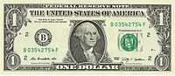](http://en.wikipedia.org/wiki/File:Onedolar2009series.jpg)

A group of candy



[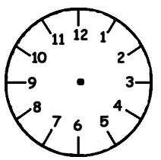](http://www.lucylearns.com/images/clock-clip-art-8.gif)