The Bear That Wasn't
Author and Illustrator Frank Tashlin
Once upon a time, in fact it was on a Tuesday, the Bear stood at the edge of a great forest and gazed up at the sky. Away up high, he saw a flock of geese flying south...
He knew when the geese flew south and the leaves fell from the trees, that winter would soon be here and snow would cover the forest. It was time to go into a cave and hibernate.
And that was just what he did.
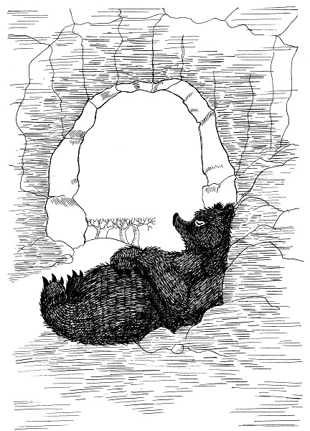
Not long afterward, in fact it was on a Wednesday, men came...lots of men with steamshovels and saws and tractors and axes...
They worked, and worked, and worked, and finally they built a great, big, huge, factory, right OVER the TOP of the sleeping Bear’s cave.
The factory operated all through the cold winter.
And then it was SPRING again.
Deep down under one of the factory buildings the Bear awoke. He blinked his eyes and yawned...
He walked up the stairs to the entrance and stepped out into the bright spring sunshine. His eyes were only half opened, as he was still very sleepy.
His eyes didn’t stay half opened long. They suddenly POPPED wide apart. He looked straight ahead. Where was the forest? Where was the grass? Where were the trees? Where were the flowers?
WHAT HAD HAPPENED?
Where was he? Things looked so strange. He didn’t know where he was...
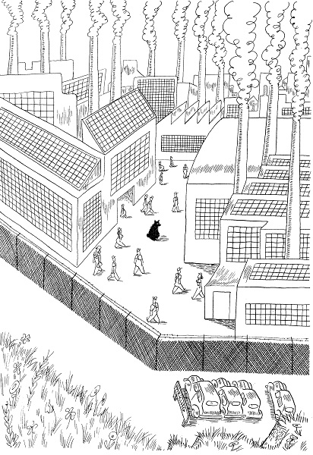
Just then a man came out of a door.
“Hey, you get back to work,” the man said. “I’m the Foreman and I’ll report you for not working.”
The Bear said, “I don’t work here. I’m a Bear.”
The Foreman laughed very loud. “That’s a fine excuse for a man to keep from doing any work. Saying he’s a bear.”
The Bear said, “But, I am a Bear.”
The Foreman stopped laughing. He was very mad.
“Don’t try to fool me,” he said. “You’re not a Bear. You’re a silly man who needs a shave and wears a fur coat. I’m going to take you to the General Manager.”
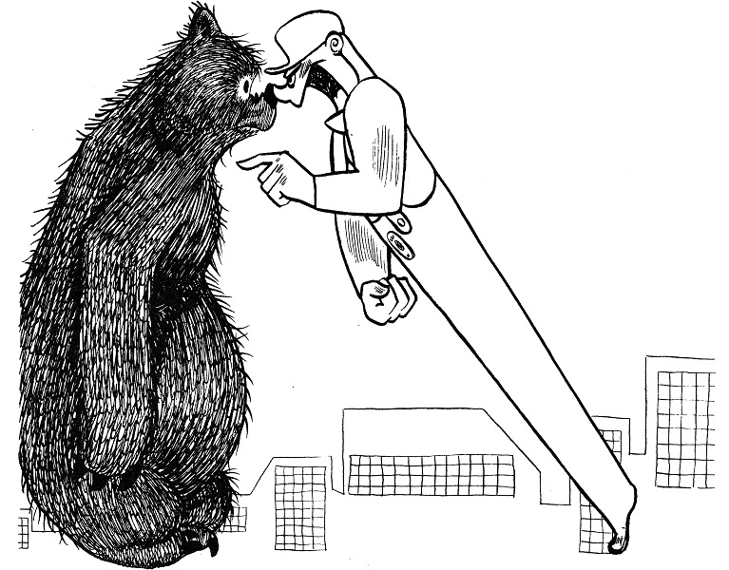
The General Manager was mad, too. He said, “You’re not a Bear. You’re a silly man who needs a shave and wears a fur coat. I’m going to take you to the Third Vice President.”
The Bear said, “I’m sorry to hear you say that . . . You see, I am a Bear.”
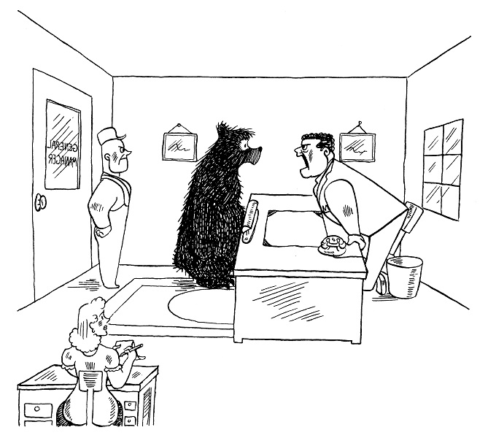
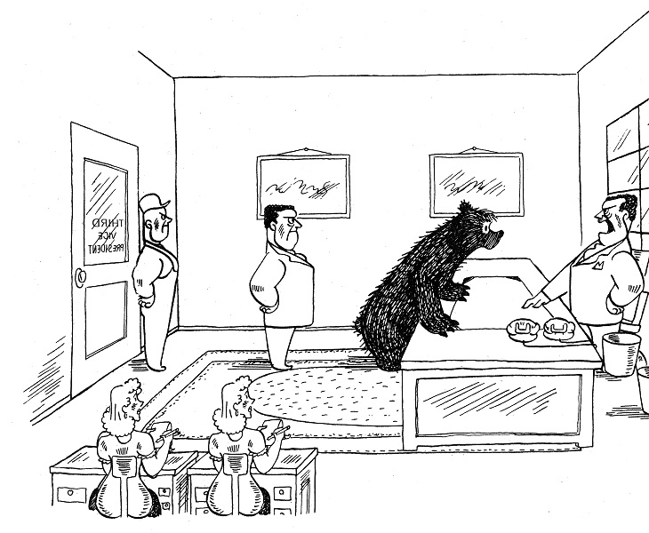
The Second Vice President was more than mad or madder. He was furious...
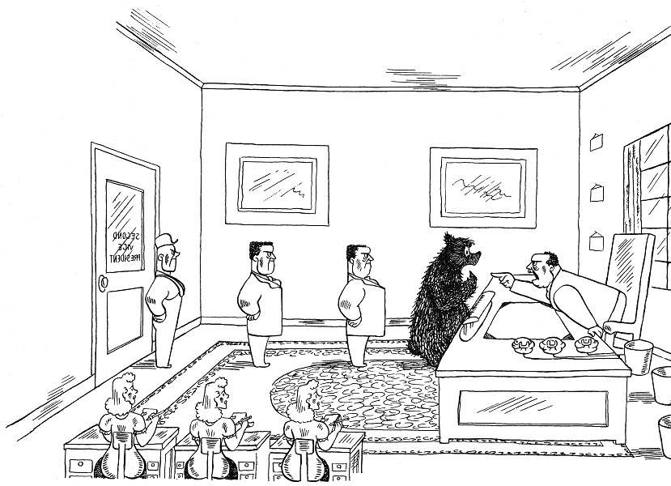
The Bear pleaded, “This is a dreadful error, you know, because ever since I can remember, I’ve always been a Bear.”
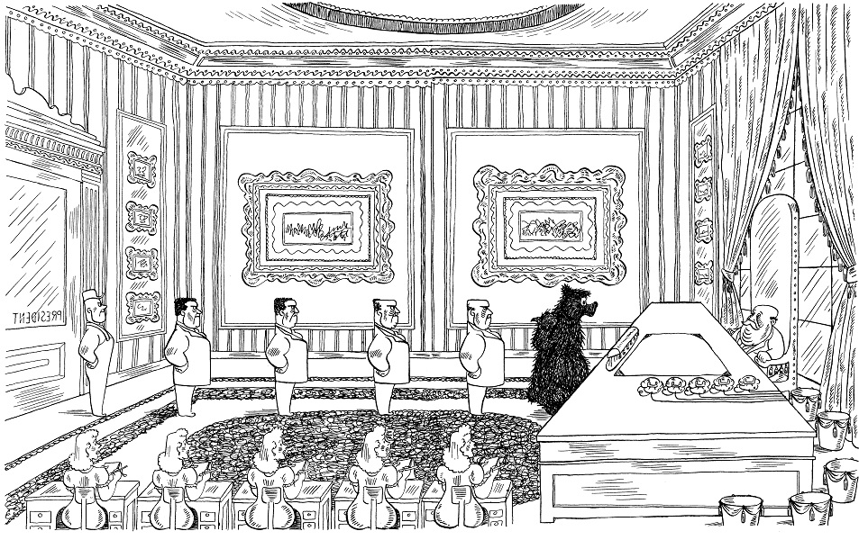
“Listen,” the Bear told the President. “I don’t work here. I’m a Bear, and please don’t say I’m a silly man who needs a shave and wears a fur coat, because the First Vice President and the Second Vice President and the Third Vice President and the General Manager and the Foreman have told me that already.”
“Thank you for telling me,” the President said. “I won’t say it, but that’s just what I think you are.”
The Bear said, “I’m a Bear.”
The President smiled and said, “You can’t be a Bear. Bears are only in a zoo or a circus. They’re never inside a factory and that’s where you are; inside a factory. So how can you be a Bear?”
The Bear said, “But I am a Bear.”
The President said, “Not only are you a silly man who needs a shave and wears a fur coat, but you are also very stubborn. So I’m going to prove it to you, once and for all, that you are not a Bear.”
The Bear said, “But I am a Bear.”
AND SO THEY ALL GOT INTO THE PRESIDENT’S CAR AND DROVE TO THE ZOO.
“Is he a Bear?” the President asked the zoo Bears. The zoo Bears said, “No, he isn’t a Bear, because if he were a Bear, he wouldn’t be outside the cage with you. He would be inside the cage with us.”
The Bear said, “But I am a Bear.”
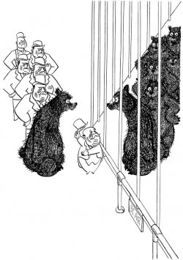

...AND SO THEY ALL LEFT THE ZOO AND DROVE SIX HUNDRED MILES AWAY TO THE NEAREST CIRCUS.
“Is he a Bear?” the President asked the circus Bears. The circus Bears said, “No, he isn’t a Bear, because if he were a Bear, he wouldn’t be sitting in a grandstand seat with you. He would be wearing a little hat with a striped ribbon on it, holding on to a balloon and riding a bicycle with us.”
The Bear said, “But I’m a Bear.”
...They left the circus and drove back to the factory.
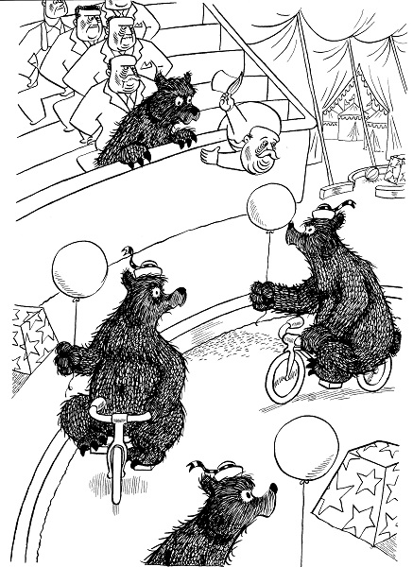
And so they put the Bear to work on a big machine with a lot of other men. The Bear worked on the big machine for many, many months.
One day a long time afterward, the factory closed down and all the workers left and went home. The Bear walked along far behind them. He was all alone, and had no place to go.
As he walked along, he happened to gaze up at the sky. Away up high, he saw a flock of geese flying south . . .
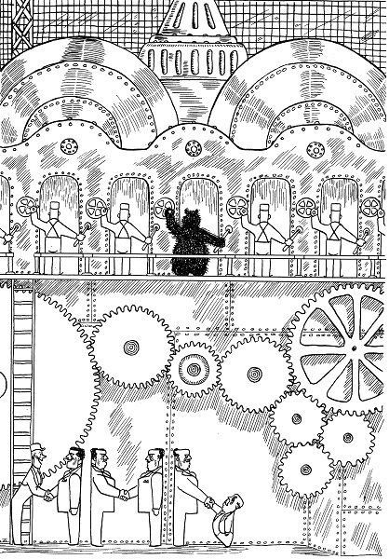
The Bear knew when the geese flew south and the leaves fell from the trees, that winter would soon be there and snow would cover the forest. It was time to go into a cave and hibernate.
So he walked over to a huge tree that had a cave hollowed out beneath its roots. He was just about to go into it, when he stopped and said, “But I CAN’T go into a cave and hibernate. I’m NOT a Bear. I’m a silly man who needs a shave and wears a fur coat.”
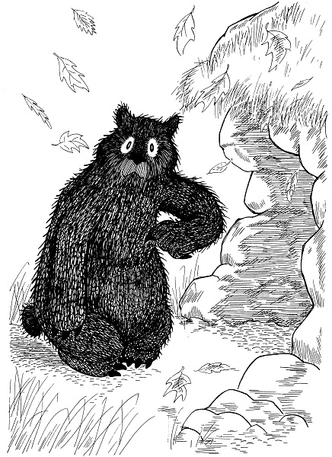
So winter came. The snow fell. It covered the forest and it covered him. He sat there, shivering with cold and he said, “But I sure wish I was a Bear.”
The longer he sat there the colder he became. His toes were freezing, his ears were freezing and his teeth were chattering. Icicles covered his nose and chin. He had been told so often, that he was a silly man who needed a shave and wore a fur coat, that he felt it must be true.
So he just sat there, because he didn’t know what a silly man who needed a shave and wore a fur coat would do, if he were freezing to death in the snow. The poor Bear was very lonely and very sad. He didn’t know what to think.
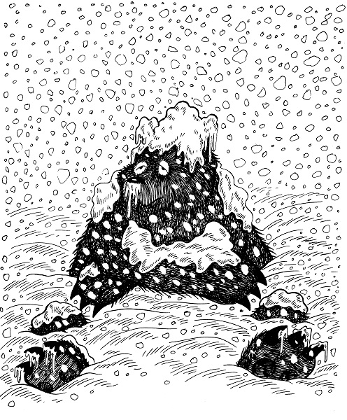
Then suddenly he got up and walked through the deep snow toward the cave. Inside, it was cosy and snug. The icy wind and cold, cold snow couldn’t reach him here. He felt warm all over.
He sank down on a bed of pine boughs and soon he was happily asleep and dreaming sweet dreams, just like all bears do, when they hibernate.
So even though the FOREMAN and the GENERAL MANAGER and the THIRD VICE PRESIDENT and the SECOND VICE PRESIDENT and the FIRST VICE PRESIDENT and the PRESIDENT and the ZOO BEARS and the CIRCUS BEARS had said, he was a silly man who needed a shave and wore a fur coat, I don’t think he really believed it, do you? No, indeed, he knew he wasn’t a silly man, and he wasn’t a silly Bear either.
¹
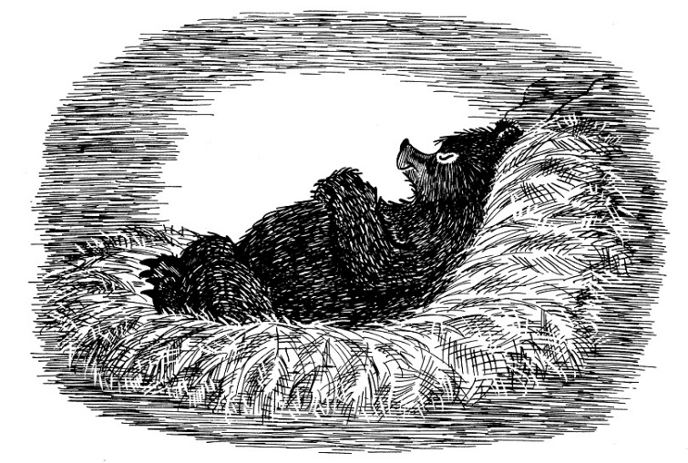

Citations
- 1 : Frank Tashlin, The Bear That Wasn’t (Mineola, NY: Dover Publications, Inc., 1995). Text and images reproduced by permission from Dover Publications.

